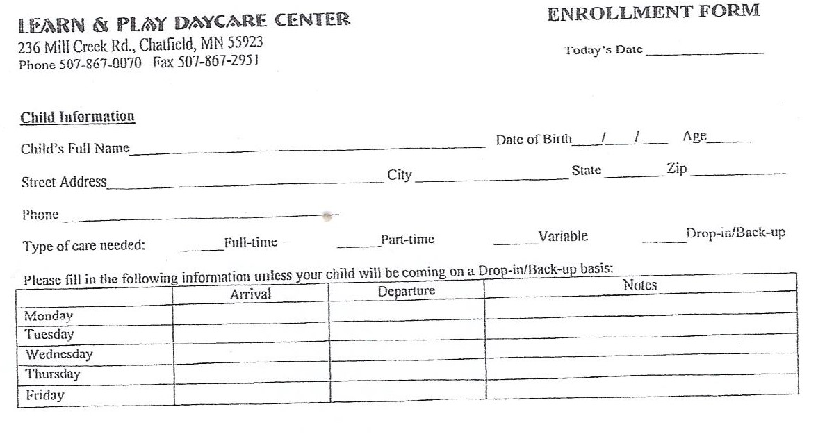

Email:____________________________________________

