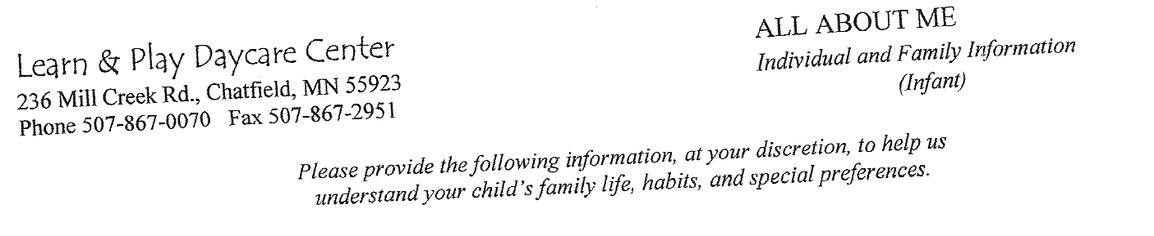

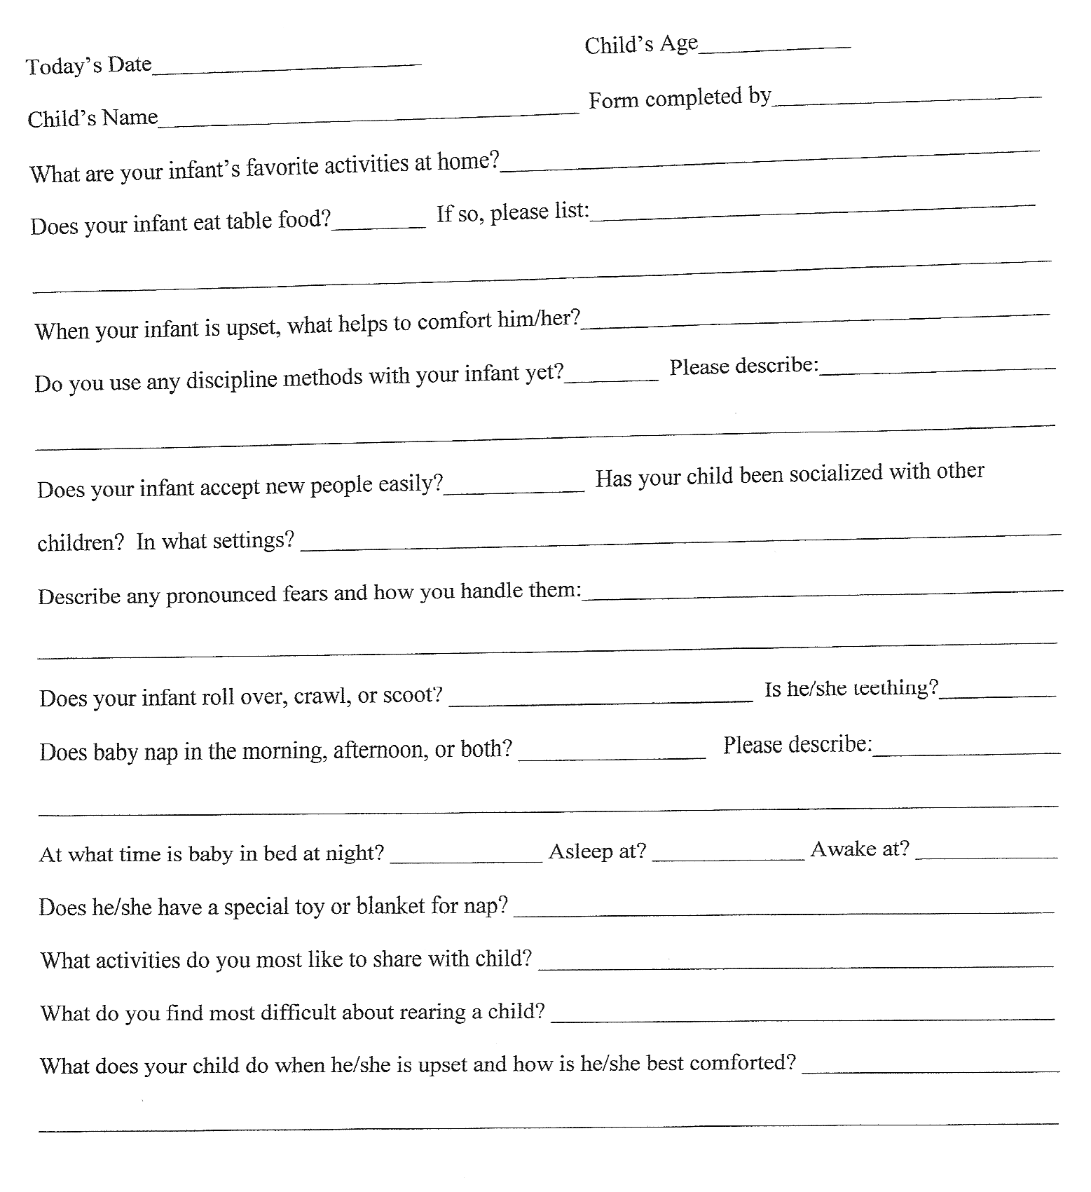

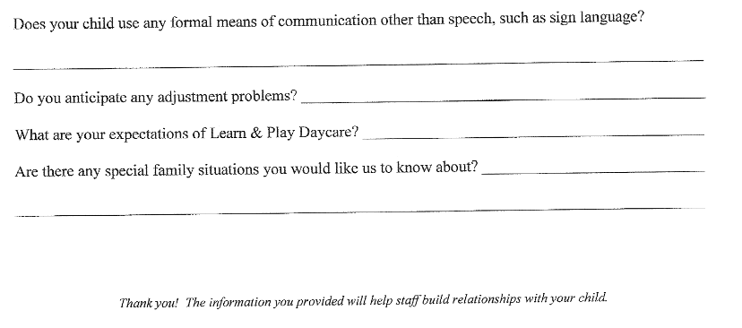

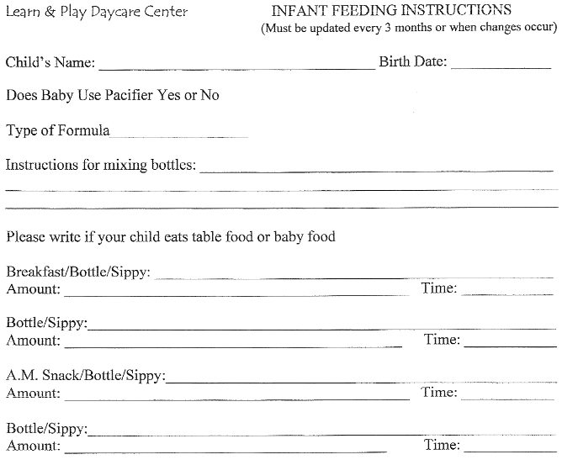

Does your Child have Any Food Allergies: Y/N :__________________

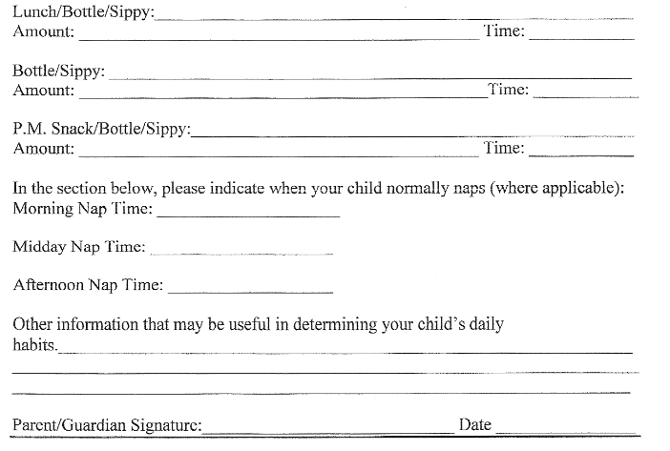

Please list Any Food your Child cannot receive: